**Project Documentation :LDU Factorization Using Elimination Matrices**

**1.Project Overview**

**Course:** Introduction to Computer Science

**Topic:**LDU Factorization Calculation

**Team:** Group No.-8

**Repository:**<https://github.com/Sauhardrai/itc_project.git>

**2.Objective:**

This website allows the users to input a matrix of any dimension and calculate its LDU (Lower Diagonal Upper) factorization. The website will display the factorization process step by step,

Showing the L,D and U matrices that result from the decomposition.

### **3.Purpose:**

This document provides an explanation of the LU Factorization method, step-by-step, and applies it to an example. This documentation is prepared by a team of four members.

2.**Team Members and Contributions**

| **Name** | **Role** | **Contribution** |
| --- | --- | --- |
| **Arjun Kadam** | Quality Assurance (Testing & Debugging)and Front end developer | Conduct thorough testing and debugging of the LDU factorization code to ensure that the algorithm works correctly and efficiently.  Identify potential bugs, performance bottlenecks, or areas for improvement in the factorization process.Contributed in styling part |
| **Rakshita K Biradar** | Documentation part (Writing & Formatting) and Front end developer | Manage the documentation process to ensure that all aspects of the project are well-documented.  Ensure that resources are allocated efficiently and that risks are managed.Contributed in the styling part. |
| **Rohit Malviya** | Project Manager and Front end developer | Oversee the project's progress and ensure deadlines are met.  Coordinate between team members and stakeholders to ensure smooth communication.Contributed in the styling part. |
| **Sauhard Kumar** | Algorithm Design & Optimization and Backend developer | Design the core algorithm for LDU Factorization along Four Members, ensuring its correctness, efficiency, and scalability.Designed HTML and Java-script web pages. |

**4.Project Workflow and Tools**

* **Tools Used:**

1. **Version Control:** GitHub
2. **Communication:** Google Meet, Gmail ,Whatsapp
3. **Languages:** HTML,CSS,Java-Script

* **Workflow:**

1. We adopted the GitHub Flow for collaboration, beginning with separate branches for each feature and merging them after a thorough review.

**5. Development Process**

**1. Phase 1 - Planning:**

○We group members discussed among ourselves how to execute the things.

○ Established the project scope and assigned tasks to the team members.

○ Created a GitHub repository and set up basic files and folders.

**2. Phase 2 - Implementation:**

**○** "Then, the UI was designed with input fields for matrix dimensions and elements.

○ The frontend and backend code were integrated, and styling was applied for a

Netflix-inspired appearance.

* We tried many times but we are unable to write a java file for LDU(mainly inverse section).

**3. Phase 3 - Review and Testing:**

**○** Regular meetings were held to evaluate progress and merge code updates.

○ Bugs and areas for improvement were identified and addressed collaboratively by the

Team.

○Ongoing discussions were held to simplify and enhance the user-friendliness of the

project.

**6. Communication And Discussion About Project**

**Google Meeting Screenshots:**

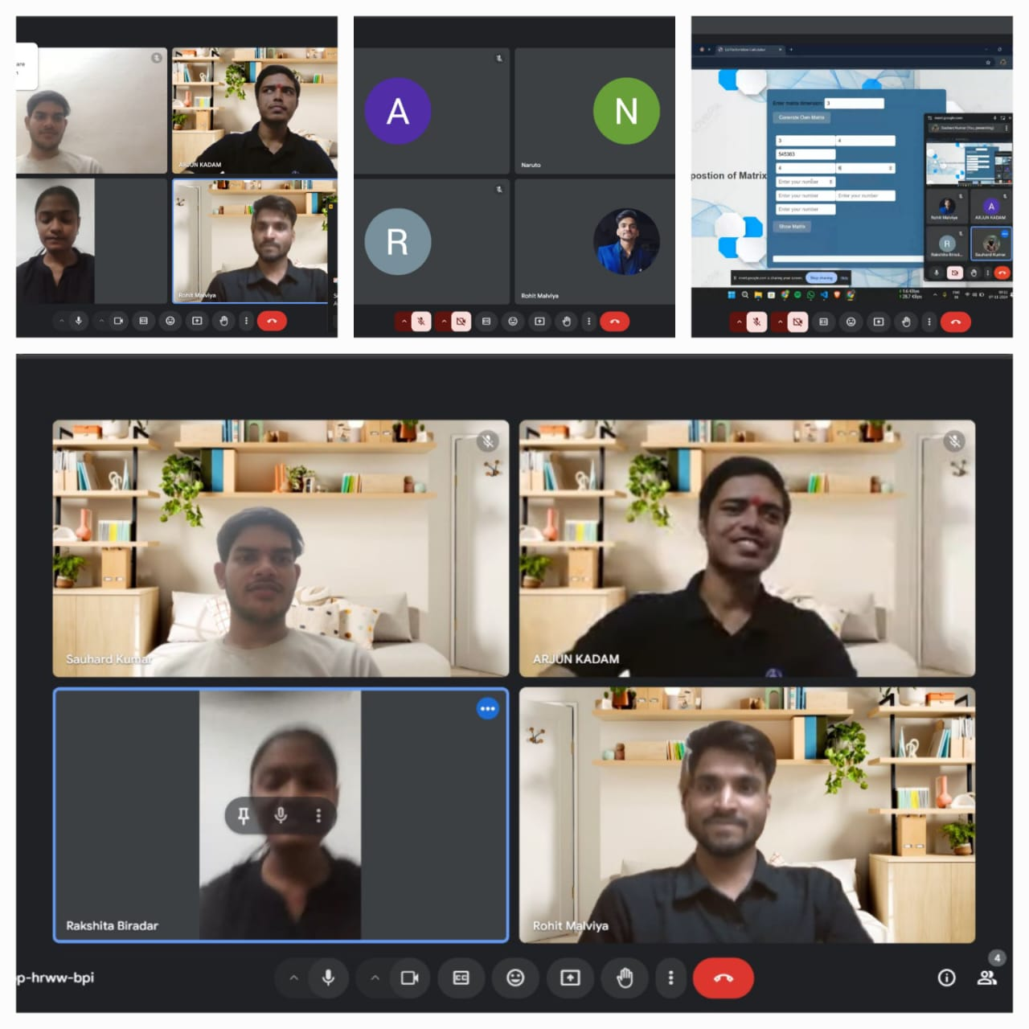

**G-mail Screenshot:**

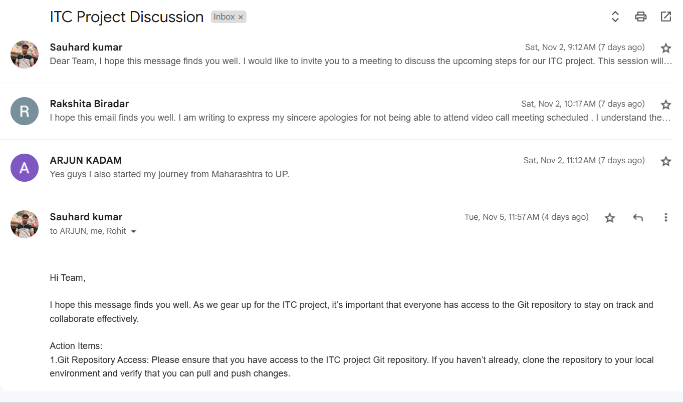

**Online Video Call Meeting:** [video meeting.mp4](https://drive.google.com/file/d/1hhW5fMpdL7R2FhS3y-BA_qrwy_NLuwwi/view?usp=sharing)

**7.Steps for LDU Factorization:**

1. Start with the matrix A:

* + Let A be an n × n square matrix to be decomposed.

2 .Decompose into LU (without the diagonal):

* + Perform Gaussian elimination on the matrix A to obtain an upper triangular matrix U and a lower triangular matrix L, where L contains ones on the diagonal.
  + During the elimination process, the pivots used to eliminate entries below the diagonal will be stored.

3.Extract the Diagonal Matrix D:

* + Once the LU decomposition is complete, the diagonal matrix D is constructed by taking the pivot elements from the matrix U (or equivalently, from the diagonal of the modified matrix after Gaussian elimination).

4.Adjust the L and U Matrices:

After separating the pivot elements into D, adjust the L and U matrices accordingly:

* + - The lower triangular matrix L will be modified to hold the multipliers from the elimination process.
    - The upper triangular matrix U will contain the final upper triangular form after elimination, excluding the diagonal elements which are now in D.

Final Result:

The matrix A is now represented as the product of L, D, and U:

A=L .D.U

**Working Model Pic Of Our Project:**

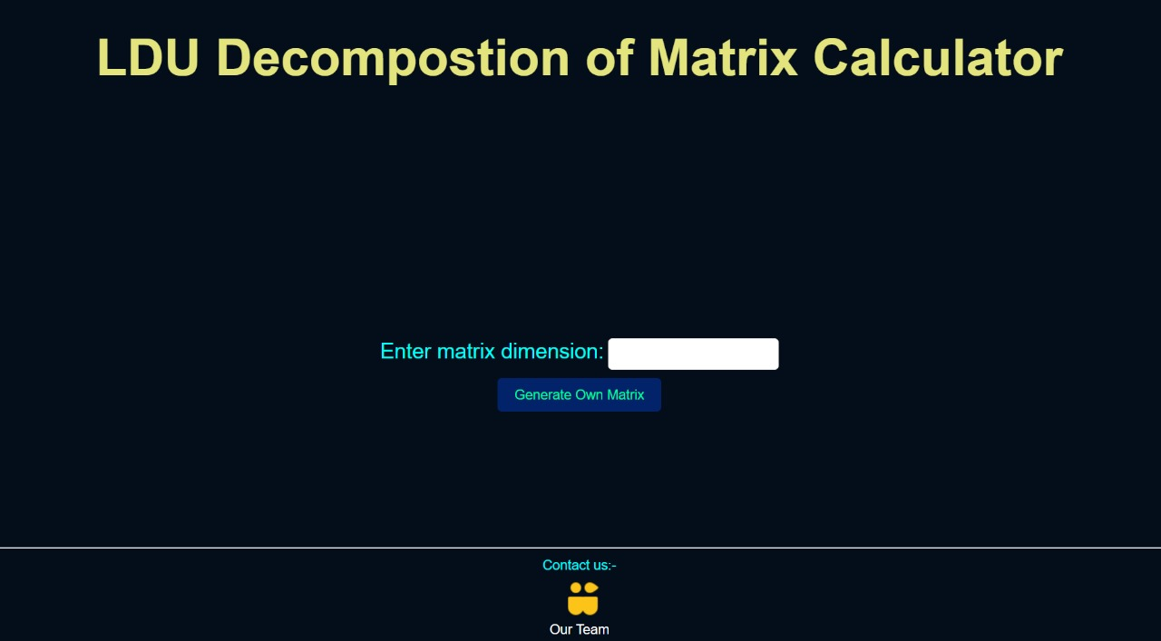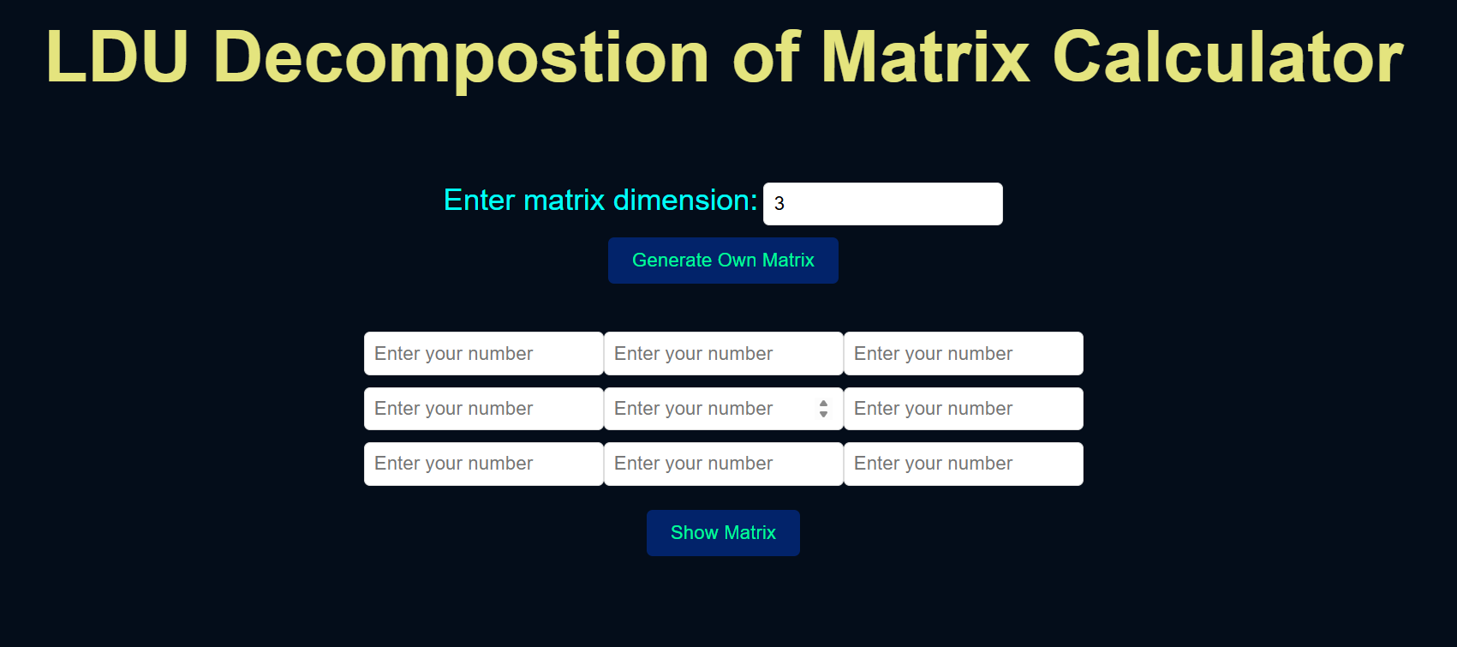

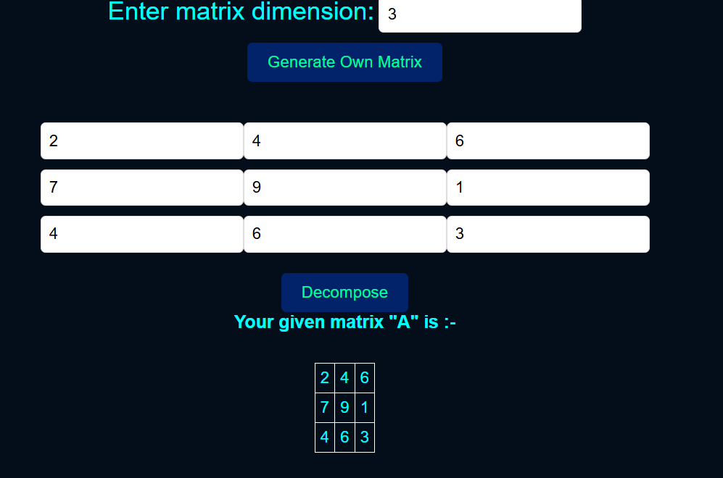

**8.GitHub Activity and Contribution**

**1.Arjun Kadam 2.Rakshita K Biradar**

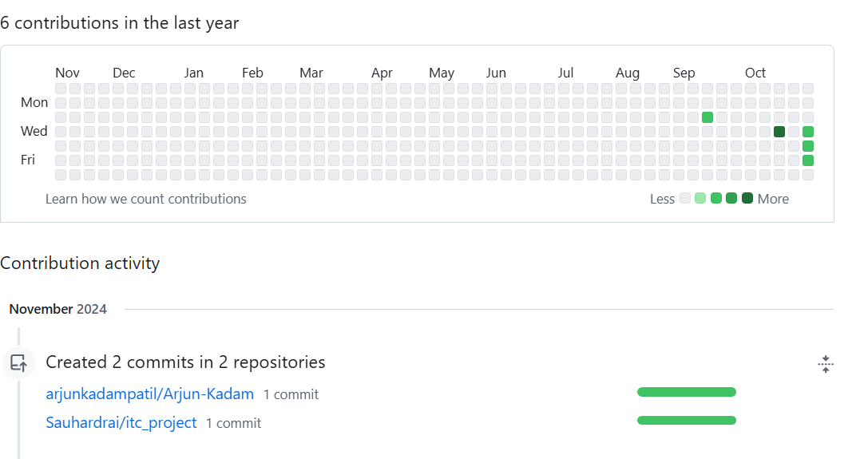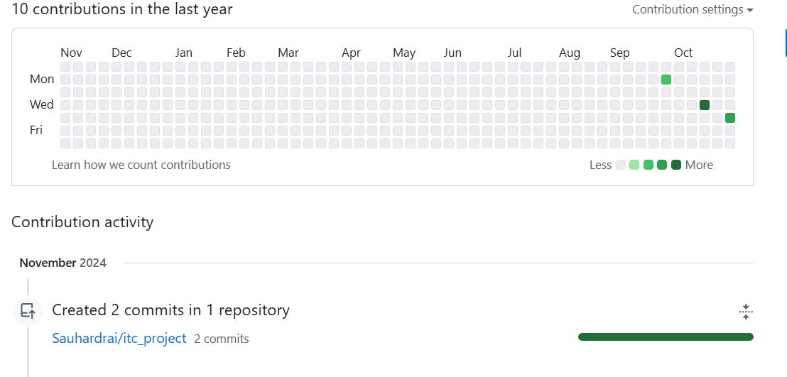

**3.Rohit Malviya 4.Sauhard Kumar**

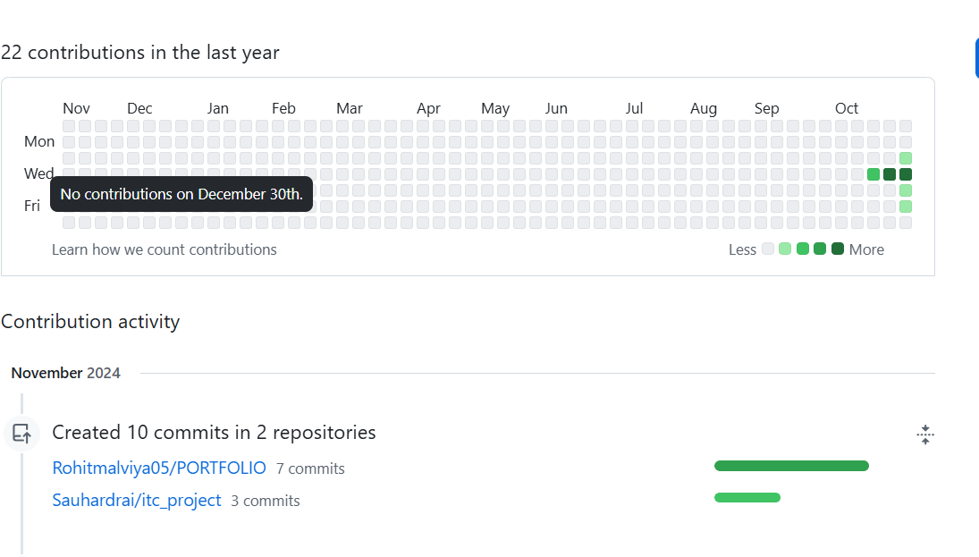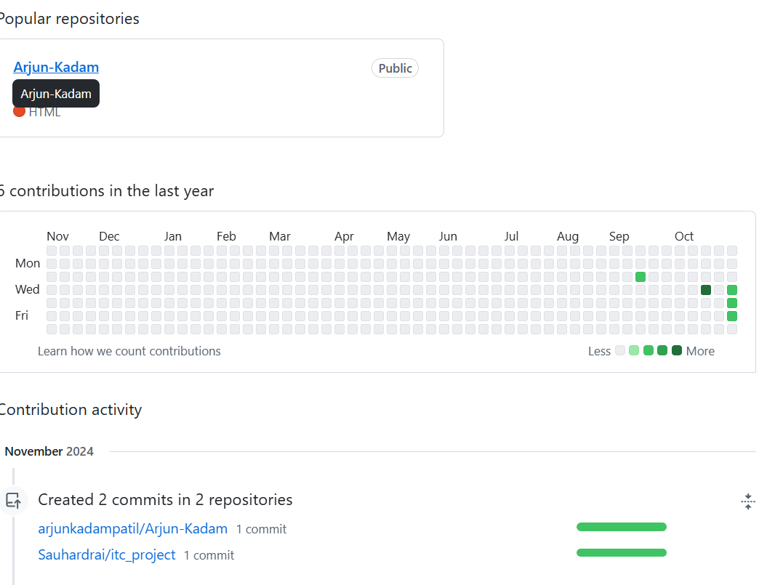

**9.Project Features**

* Matrix Input Interface: Provides an interactive way for users to specify the dimensions and elements of the matrix.
* LDU Decomposition: Performs a detailed, step-by-step breakdown of the input matrix into its L, D, and U components.
* **Scalable**:Handles both small and large matrices, suitable for high-performance computing.
* **Customizable Structure**:Allows flexible partitioning of the matrix into four parts based on problem needs.
* **Integration with Numerical Libraries**:Compatible with existing libraries like LAPACK, NumPy, and Eigen.

**10.Conclusion**

The LDU Factorization along Four Members approach provides a robust and efficient method for decomposing large matrices into their constituent parts—lower triangular, diagonal, and upper triangular matrices.

Key benefits include:

* **Improved Performance**: Faster computation through modular decomposition.
* **Scalability**: Efficient handling of both small and large matrices.
* **Flexibility**: Customizable to suit various matrix types and problem structures.
* **Parallelism**: Enables parallel computing for large datasets or high-performance applications.

**11. References**

● Textbooks and online resources on LDU factorization.

● GitHub repository and documentation standards.

●online video- <https://youtu.be/VlPiVmYuoqw?feature=shared>

**For further information: Contact Below Member**

